**Danielsen**, H.E.H., Hjelset, A.M., Bluhm, B.A., Hvingel, C., and Agnalt, A.-L. 2019. A first fecundity study of the female snow crab *Chionoecetes opilio* Fabricius, 1788 (Decapoda: Brachyura: Oregoniidae) of the newly established population in the **Barents Sea**. Journal of Crustacean Biology. 39(4):485-492.

*Institute of Marine Research, Bergen, Norway.*

* Species introduced some time prior to 1996.
* Genetic analysis shows close relationship with Pacific populations.
* Landings currently above 10000 tonnes annually.
* Sampling:
  + Sampling by traps and Campelen 1800n shrimp trawl.
  + n = 185 females total, 47mm CW to 101mm CW (about 10% of samples are >= 90mm CW, *really large*).
  + Clutches frozen, then thawed.
  + 3 x 200 eggs in subsample per clutch, weighed to 0.1mg precision.
* Allometry log10 F = -0.63 + 2.94 log10(CW). *Only full clutches considered?* n = 177. *Maturity stage (primiparous vs multiparous) ignored*, though shell conditions are measured (odd).
* Egg staging seems to have been performed.
* Mean egg dry weight was 0.065mg.

________________________________________________________________

**Kolts** J. M., Lovvorn J. R., North C.A., Janout M. A. (2015). Oceanographic and demographic mechanisms affecting population structure of snow crabs in the northern **Bering Sea**. Marine Ecology Progress Series. 518: 193-208.

*Institute for Polar and Marine Research, Climate Sciences/Observational Oceanography, Bremerhaven, Germany.*

* Chirikov Bassin, East Sector and West Sector
* Most snow crabs in that region have a CW of <55mm and often much smaller.
* Sampling:
  + Sampling by 4 m beam trawl with 37mm stretched mesh, 89 tows, 53 stations, ~2 knots.
  + 32 multiparous, CW: 40-68 mm
  + 41 primpiparous, CW 40-64 mm
  + Total N= 73 for females and fecundity analysis
  + Subsample of eggs = 250-300 eggs
* Fecundity analysis: y = 0.0292 x3.4026, R2 = 0.82
* Clutch size Multiparous > Primiparous (ANCOVA, p < 0.001)
* Mean mass per individual egg was similar for primiparous vs multiparous females with recently extruded clutches.
* Unable to calculate fertilization rates
* Most females collected had eggs at stages 1 to 3 (Moriyasu)
* Estimation of percentage of clutch remaining, percentage of yolk, and embryonic development stage.

________________________________________________________________

Jewett SC (1981) Variations in some reproductive aspects of

female snow crabs Chionoecetes opilio. J Shellfish Res 1:

95−99 –

* **Cited but non existant?**

________________________________________________________________

Paul et al. 1997

* **Cited but non existant?**

________________________________________________________________

**Comeau** M., Starr M., Conan G. Y., Robichaud G., Therriault J.-C. (1999). Fecundity and duration of egg incubation for multiparous female snow crabs (*Chionoecetes opilio*) in the fjord of **Bonne Bay**, Newfoundland. *Can. J. Aquat. Sci*. 56: 1088-1095.

*DFO-MPO, Moncton, Mont-Joli.*

* Bonne Baie, 1991
* Fecundity analysis (ln of #eggs, ln of CW):
* Stage 2, orange eggs, n = 53, y= 2.9486x - 1.3224, R2 = 0.96
* Stage 4, brown eggs, n = 17, y = 2.2876x + 1.2684, R2 = 0.72

________________________________________________________________

**Divine** L. M., Mueter F. J, Kruse G. H., Bluhm B. A., Jewett S. C., Iken K. (2019) New estimates of weight-at-size, maturity-at-size, fecundity, and biomass of snow crab, *Chionoecetes opilio*, in the **Arctic Ocean off Alaska**. Fisheries Research 218: 246-258.

*College of Fisheries and Ocean Sciences, University of Alaska Fairbanks, Fairbanks, AK, United States.*

* 13 surveys in the Chukchi Sea and 7 in the Beaufort Sea.
* Sampling
  + Plumb staff beam trawl (PSBT), 2.257 m opening, 7 mm net mesh, 4 mm cod end liner.
  + N = 322 females for fecundity analysis
* Fecundity analysis: y = 2.9x - 1.61, R2 = 0.50
* CW: 38-65 mm (according to graph)
* Biomass, abundance, sustainable yield, maturity, crab weight and size also examined.

________________________________________________________________

**Sainte-Marie** B. (1993) Reproductive cycle and fecundity of primiparous and multiparous female snow crab, *Chionoecetes opilio,* in the **Northwest Gulf of Saint Lawrence**. Can. J. Fish. Aquat. Sci. 50: 2147-2156.

*DFO-MPO, direction des sciences des pêches, Institut Maurice-Lamontagne, Mont-Joli, QC, Canada.*

* Baie Sainte-Marguerite
* Sampling:
  + 3m beam trawl, 3 locations, 3 depth strata.
  + N= 318 females
  + CW: standard: 57.4 mm
* “Fecundity was determined as the ratio of brood weight to mean egg weight”
* 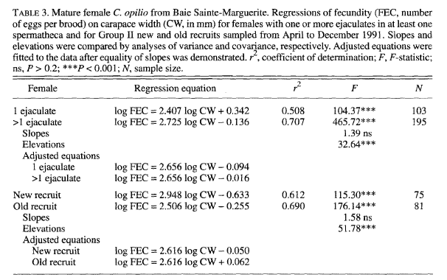

________________________________________________________________

**Webb** J. B., Slater L. M., Eckert G. L., Kruse G. H. (2016). The contribution of fecundity and embryo quality to reproductive potential of eastern **Bering Sea** snow crab (*Chionoecetes opilio*). Can. J. Aquat. Sci. 73: 1-15.

*University of Alaska Fairbanks, School of Fisheries and Ocean Sciences, Juneau, AK, USA. Department of Fish and Game, Division of Commercial Fisheries, Juneau, AK, USA.*

* Sampling:
  + Annual stock assessment bottom trawl surveys conducted by the US NOAA National Marine Fisheries Service.
  + N = 853 females
  + CW: 40-85 mm according to graphs
* “Fecundity was estimated by division of te dry mass of the egg clutch stripped from the pleopods by mean embryo dry mass”
* Divided by shell conditions, SC2 – new shell, SC3 – old shell, SC4 – very old shell, SC5 – very very old shell.
* Fecundity early (summer) vs late (spring) in the brooding comparison.
* 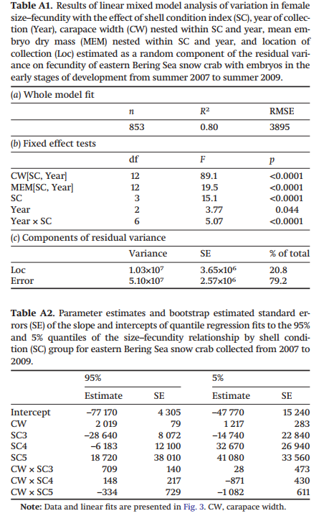

________________________________________________________________

Elner R.W., Gass C. A. (1983). Observations on the Reproductive condition of Female Snow Crabs from NW Cape Breton Island, November 1983. CAFSAC Research Document 84/14.

*Invertebrates and Marine Plants Division, Fisheries Research Branch, Department of Fisheries and Oceans, Biological Station, St. Andrews, NB, Canada.*

* Sampling:
  + Snow Crab Management Area 1.
  + Comercial vessel using a Danish seine.
  + Frozen-thawed.
* Weight of one egg estimated with 4 subsamples of 30 (120 eggs total).
* Fecundity analysis: n=25 (for each stage – I without eyespots and II with eyespots)
  + Stage I without eyespots: y= 3092.23x^0.70, R2 = 0.223
  + Stage II with eyespots: y = 147.17x^1.42, R2 = 0.500
* Unable to compare primi vs multiparous.

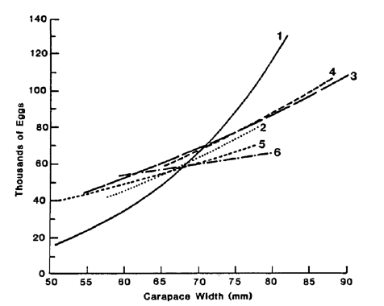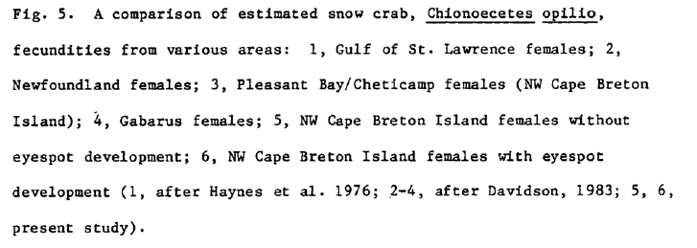

Reference to other study (Davidson, 1983):

* NW of Cape Breton Island, july 1980.
* Y= 38.4554x^1.7649, R2= 0.6347.
* Mean fecundity: 74500, range: 32600-128400.

________________________________________________________________

Taylor D. M. (1996). Aspects of multiparous snow crab (*Chionoecetes opilio*) fecundity in insular Newfoundland waters

*Memorial University, St. John’s, Newfoundland, Canada.*

* Bonavista Bay, Conception Bay, Nearshore Avalon.
* Sampling:
  + Baited traps
  + N = 350 mature females
  + CW = 44-85mm, mean of 65.8
  + Number of eggs = 8589 – 103112, mean of 44658.
* Fecundity: y = 0.7493x^2.6108.
* No R2 value.
* Reference to other studies:

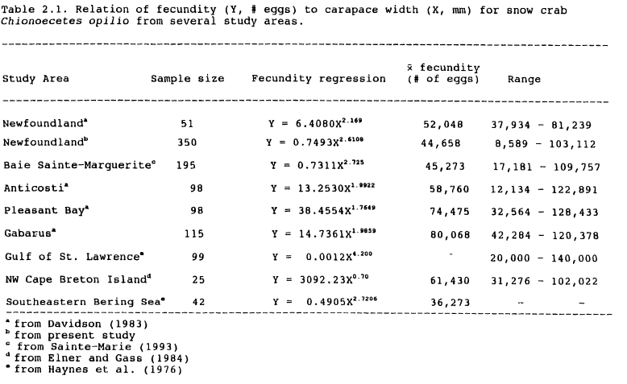

________________________________________________________________

# Fecundity Differences between Primiparous and Multiparous Female Alaskan Tanner Crab (Chionoecetes bairdi)

David A. Somerton and William S. Meyers

*Journal of Crustacean Biology*

Vol. 3, No. 2 (May, 1983), pp. 183-186